# CS 255 System Design Document

## UML Diagrams

### UML Use Case Diagram

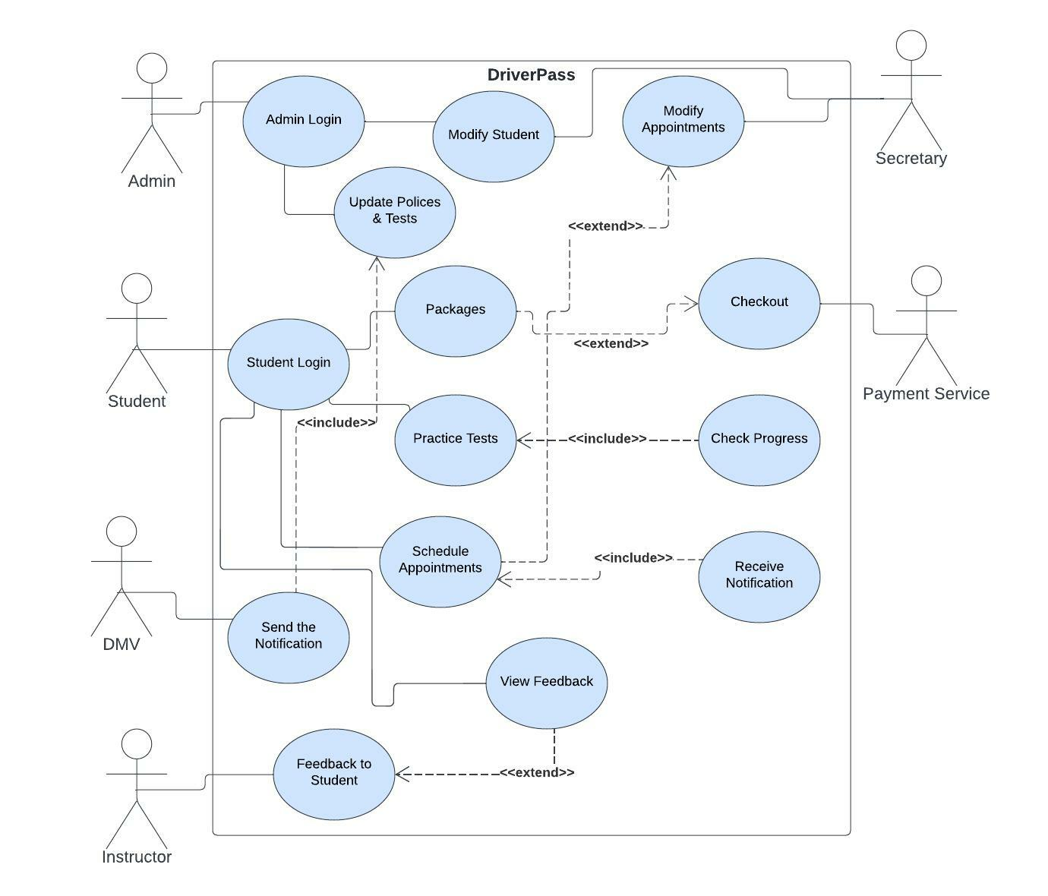

### Graphical user interface, application, Teams Description automatically generatedUML Activity Diagrams

### UML Sequence Diagram

### UML Class Diagram

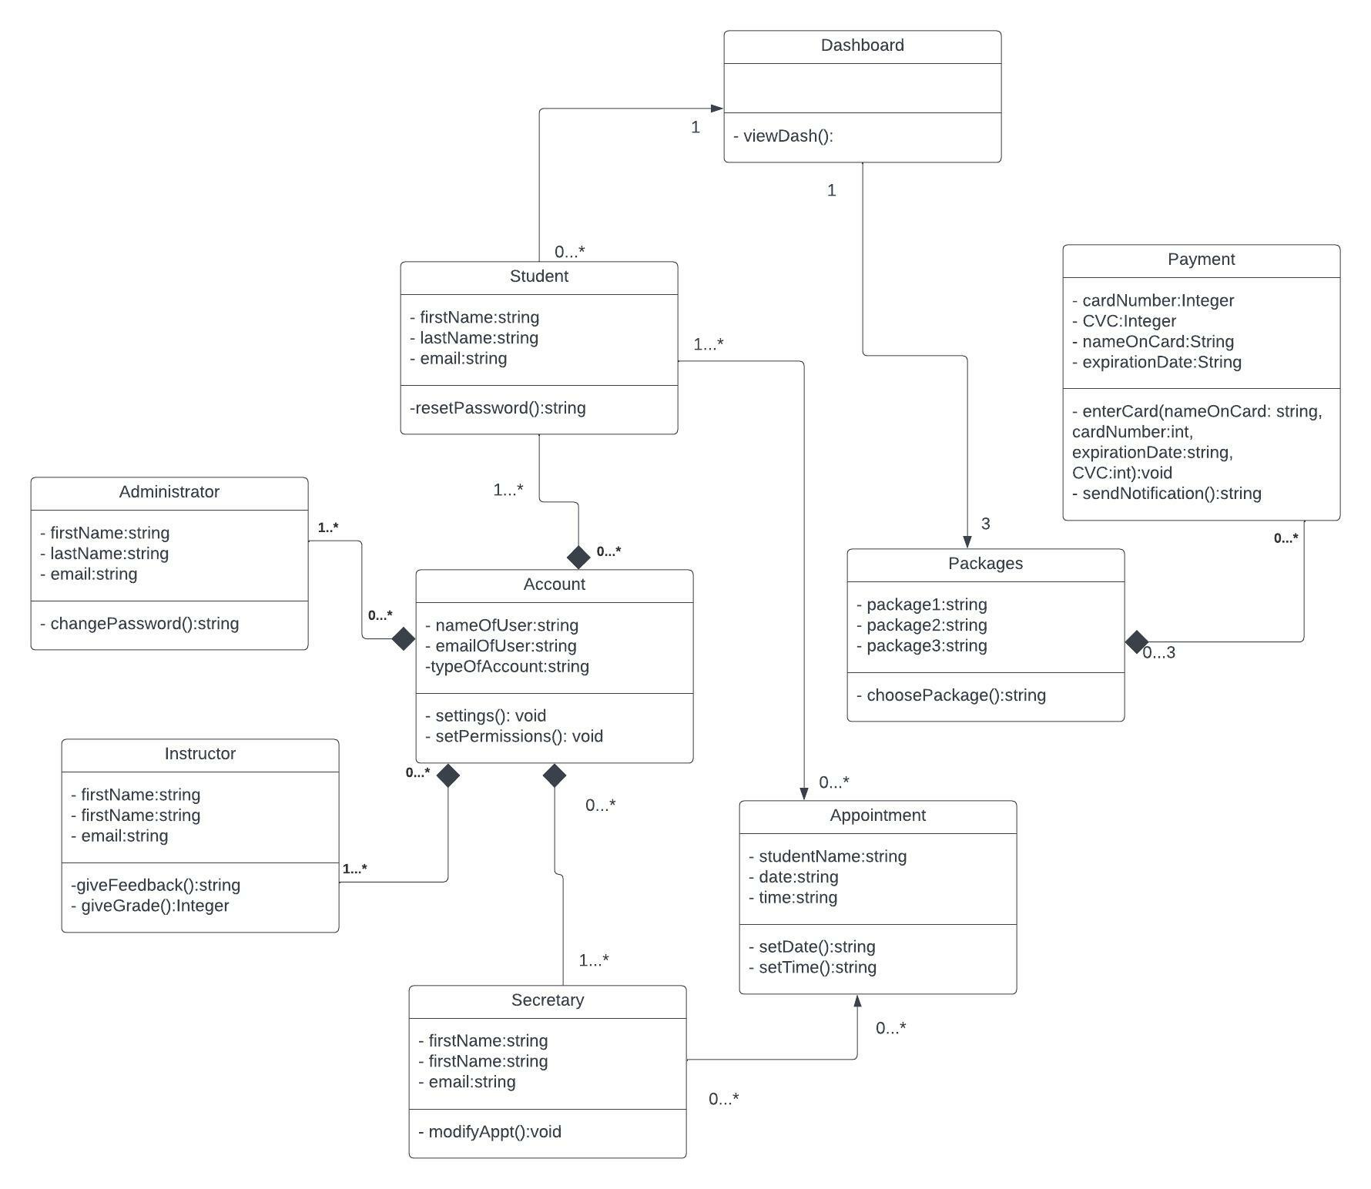

## Technical Requirements

Based on the diagrams, the DriverPass system shall have:

**Functional Requirements:**

* Validate user information when logging in.
* Show the user 3 packages to choose from for driving lessons.
* Allow for a user to make, cancel, and modify appointments.
* Allow for payments online for the packages.
* Connection to the DMV website to keep policies, practice questions, rules, and procedures up to date.
* The system shall include all online classes and practice tests.

**Non-Functional Requirements:**

* The system should have a web-based application and be accessible on mobile devices.
* The system will be accessible via the internet.
* The system will need a cloud-based storage.
* The system needs to run on all platforms such as Windows, Linux, and Mac.
* The system should not lag.